RI22

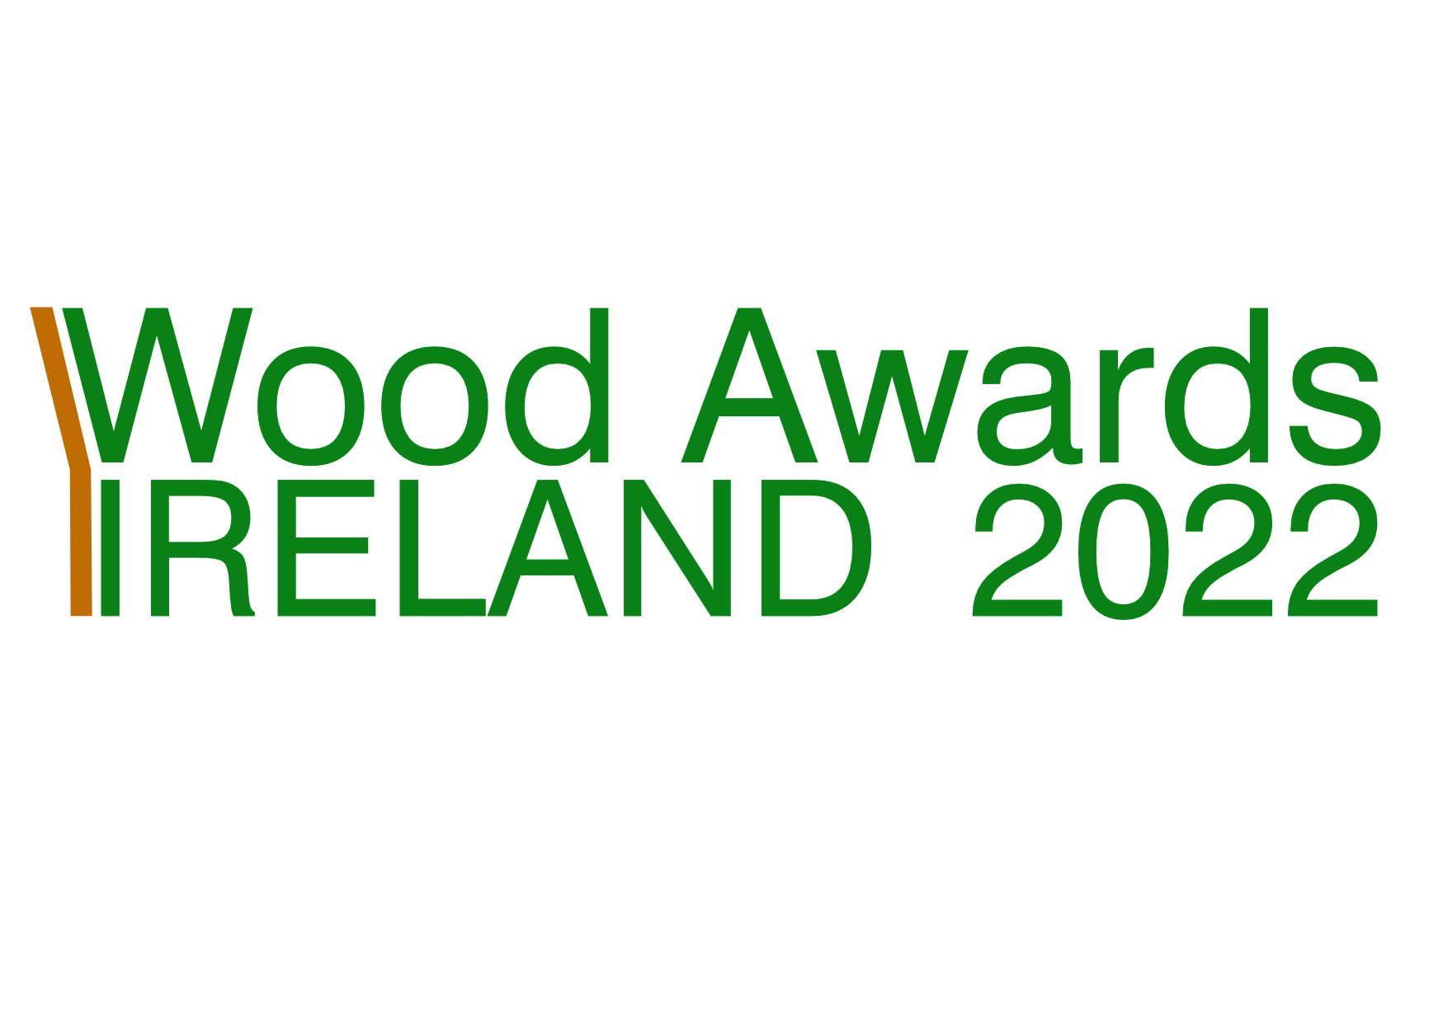

.

|  |  |
| --- | --- |
| APPLICATION FORM FOR **ROTARY STUDENT ENVIRONMENT AWARD** | |
| Name | |
| College | |
| If a collaborative entry include name of other students but only mobile number, email address of student who submits the application form along with contact information of college tutor and/or co-ordinator as they will be invited to award ceremony if project is successful.  Other entrants if collaborative project:  Mobile no. of submitter: Email address:  College tutor/supervisor  Mobile no. Email address | |
| Project name | |
| Start and completion date | |
| Study year  Undergraduate student study year (open to all undergraduates, regardless of year of study and also open to undergraduates who have qualified during the past three years). | |
| Description of project including main points that outline its potential in helping to achieve net zero either in its present form or with further research and development. Also outline further research, if any, to explore its future potential. Maximum: 300 words. | |
| Signed | Date |

Email to info@wood.ie. Relevant dates:

* Closing date for entries**: 22 September 2022.**
* Compilation of shortlist by judges October 2022 and award winners and colleges notified **27 October** 2022.
* Awards ceremony – provisional date **17 November 2022**; provisional venue, Farmleigh, Dublin, subject to change.

Donal Magner

Environment Lead

Rotary Ireland

2 July 2022