RI

**ROTARY THIRD LEVEL STUDENT ENVIRONMENT AWARD**

Achieving Net Zero with Trees and Wood

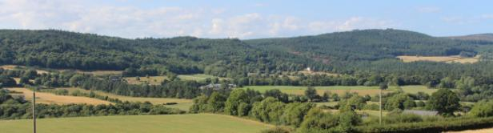

TRANSITIONING to a net-zero world is regarded by the UN as one of the greatest challenges facing humankind. To keep global warming to no more than 1.5°C, emissions of green house gas (GHG) need to be reduced to net zero by 2050. This environment challenge has been acknowledged by Rotary International for a number of years. More than $18 million in Foundation global grant funding was allocated to environment-related projects over a five year period before Rotary formally added a new area of focus in 2020: supporting the environment.

Rotary Student Environment Award – Achieving Net Zero with Trees and Wood

ROTARY IRELAND plays its part in organising a wide range of environment related projects from tree planting to youth projects. Now it is launching the Rotary Student Environment Award to encourage third level students to submit projects on how woodlands, forests and the wood from the trees can contribute to achieving net zero.

The focus is on trees because sustainable forestry is regarded globally as vital in achieving net zero. The role of forestry is acknowledged at forest level in carbon sequestration and carbon storage in wood and wood products where it displaces fossil based materials in construction and energy. "Afforestation is the single largest land-based climate change mitigation measure available to Ireland," maintains Ireland's Climate Action Plan, *Our Shared Future* which adds: "Using wood and wood-based products for construction is a sustainable substitute for conventional carbon-heavy construction products, such as concrete, brick and steel."

The Rotary Student Environment Award is a project to promote research in climate change mitigation. It is aimed at third level undergraduate students from a wide range of disciplines including, forestry, architecture, ecology, engineering, science, horticulture, design, agriculture, land management, bioenergy, product development, wood working and restoration. The challenge is to research and submit a project on any element of forestry throughout the growing and production cycle including nursery, forest, end use – and reuse– with the aim of contributing to net zero by 2050. Projects can explore forests and tree species and the interaction between forestry and other land uses including agriculture which is a major GHG emitter while outside the forest, there are opportunities to feature innovative wood in all its forms, in decarbonising the economy.

Projects for the Rotary Ireland Student Environment Award are accepted from Irish undergraduate students from third level colleges in Ireland – north and south – and overseas.

**HOW TO ENTER**

1. Submit project on PDF (A4) to www.wood.ie approximately 2,000 to 3,500 words plus tables, figures and photographs if relevant. Posters also accepted.
2. Project to be accompanied by completed application form.

**Closing date**: **11th November 2022.**

**Prizes**

First prize: Rotary Student Environment Award medal and certificate plus €2,000* to pursue the project Achieving Net Zero with Trees and Wood. Commendation certificates awarded to the runner(s) up.

To be presented in conjunction with Wood Awards Ireland at a venue and date to be finalised.

The Rotary Student Environment Award is a collaboration between Rotary Ireland and Wood Awards Ireland.

*This may be increased to €4,000 for an exceptional project to fund further research.

RI 22

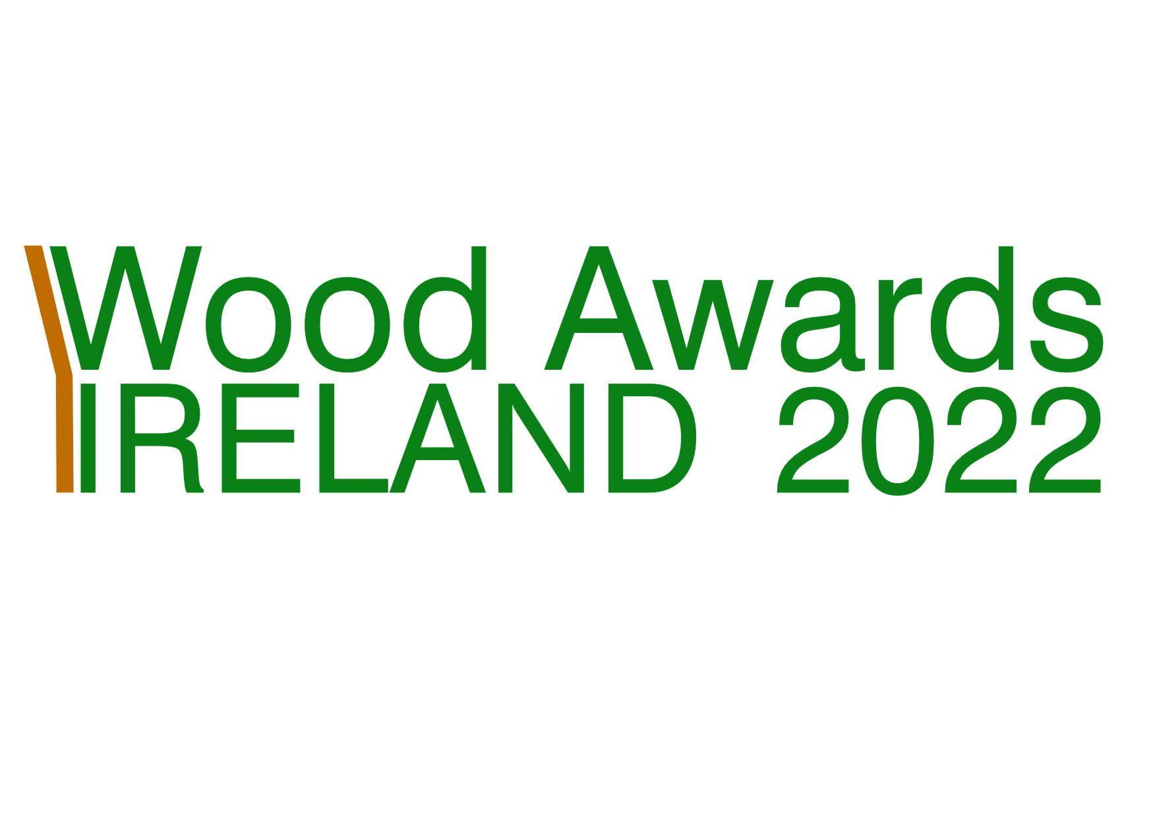

.

|  |  |
| --- | --- |
| APPLICATION FORM FOR **ROTARY STUDENT ENVIRONMENT AWARD** | |
| Name | |
| College | |
| Address of entrant(s) | |
| Project name | |
| Start and completion date | |
| Undergraduate student study year (open to all undergraduates, regardless of year of study and also open to undergraduates who have qualified during the past three years): | |
| Project team to include student(s) name or names if collaborative project. Also provide name, email addresses, and mobile phone number of college tutor and/or co-ordinator as they will be invited to award ceremony if project receives and award.  Entrant(s)  Mobile no. Email address  College tutor/supervisor  Mobile no. Email address | |
| Description of project including main points that outline its potential in helping to achieve net zero either in its present form or with further research and development. Maximum 300 words. | |
| Signed | Date |

Email to info@wood.ie. Relevant dates:

* Closing date for entries**: 11 November 2022.**
* Compilation of shortlist by judges November-December 2022.
* Awards ceremony – at a venue and date to be finalised.

Donal Magner

Environment Lead

Rotary Ireland

25 August 2022