RI
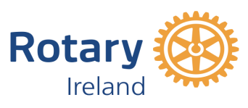
ROTARY THIRD LEVEL STUDENT ENVIRONMENT AWARD
Achieving Net Zero with Forests and Wood
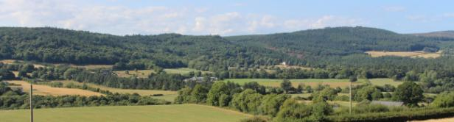

TRANSITIONING to a net-zero world is regarded by the UN as one of the greatest challenges facing humankind. To keep global warming to no more than 1.5°C, emissions of green house gas (GHG) need to be reduced to net zero by 2050. More than $18 million in Foundation global grant funding was allocated to environment-related projects over a five year period before Rotary formally added a new area of focus in 2020: supporting the environment.

2024 Rotary Student Environment Award – Achieving Net Zero with Forests and Wood
ROTARY IRELAND plays its part in organising a wide range of environment related projects from tree planting to youth projects. In 2022 it launched the Rotary Ireland Student Environment Award – Achieving Net Zero with Forests and Wood to encourage third level students to submit projects on how woodlands, forests and wood products can contribute to achieving net zero or carbon neutrality.

The focus is on trees because sustainable forestry is regarded globally as vital in achieving net zero. The role of forestry is acknowledged at forest level in carbon sequestration and carbon storage in wood and wood products where it displaces fossil based materials in construction and energy. "Afforestation is the single largest land-based climate change mitigation measure available to Ireland," maintains Ireland's Climate Action Plan, Our Shared Future which adds: "Using wood and wood-based products for construction is a sustainable substitute for conventional carbon-heavy construction products, such as concrete, brick and steel."

The award is aimed at third level students from a wide range of disciplines including, forestry, architecture, ecology, engineering, science, horticulture, design, agriculture, land management, bioenergy, product development, wood working and landscape architecture. The challenge is to research and submit a project on any element of forestry throughout the growing and production cycle from nursery to end use – and reuse– with the aim of contributing to net zero by 2050. Projects can explore the interaction between forestry and other land uses including agriculture, while outside the forest, there are opportunities to feature innovative wood in design and decarbonisation.

Projects for the Rotary Ireland Student Environment Award are accepted from undergraduate and masters students from third level colleges in Ireland – north and south.

HOW TO ENTER
a) Submit project essay (1,000 words maximum) – other material, including thesis may be attached.
b) Submit poster suitable for A1 (594 x 841mm) reproduction. Rotary will print and exhibit shortlisted projects at promotional events. Posters should be portrait rather than landscape.
c) Project to be accompanied by completed application form, available at www.wood.ie, or email info@wood.ie.

Closing date: 10th July 2024.

PRIZES UP TO €4000
Rotary Student Environment Award medal, certificate and €2,000 to the winner plus €2,000 for an exceptional project should the winner wish to pursue further research. Certificates of merit will also be presented for shortlisted projects. Presentation will be in conjunction with Wood Awards Ireland, in November 2024 in Farmleigh House, Dublin.

The Rotary Student Environment Award is a collaboration between Rotary Ireland and Wood Awards Ireland and supported by the Department of Agriculture, Food and the Marine and the Rotary Clubs of Wicklow and Dublin-Fingal.

RI 22
…………….

.
APPLICATION FORM FOR ROTARY STUDENT ENVIRONMENT AWARD
Name

College

Address of entrant(s)

Project name

Start and completion date

Undergraduate student study year (open to all undergraduates,and masters students regardless of year of study and also open to undergraduates who have qualified during the past three years):

Project team to include student(s) name or names if collaborative project. Also provide name, email addresses, and mobile phone number of college tutor and/or co-ordinator as they will be invited to award ceremony if project receives and award.
Entrant(s)

Mobile no. Email address

College tutor/supervisor

Mobile no. Email address

Description of project including main points that outline its potential in helping to achieve net zero either in its present form or with further research and development. Maximum 300 words.

Signed | Date

Email to info@wood.ie. Relevant dates:
- Closing date for entries (application form and 1,000-word submission and pdf for A1 portrait poster): 10 July 2024
- Compilation of shortlist by judges September 2024
- Awards ceremony – at Farmleigh House, November 2024

Donal Magner
Environment Lead
Rotary Ireland

